Editing A Graphic in MS Office
Select the image you wish to edit by clicking on it once with the mouse (you will see small boxes appear around the selected graphic). You can click and drag these boxes to resize the image. Hold the shift key while dragging to maintain the proportions of the image. Other picture effects and basic editing can be changed using the Picture toolbar. The Picture toolbar should appear when you click on the image. If the toolbar is not present, right-click on the picture and select "show picture toolbar, or select View|Toolbars|Picture from the menu at the top of the page.
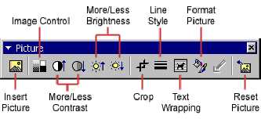
- Insert Picture: will allow you to browse to select an image to insert.
- Image Control: change to grayscale, black and white, or a watermark.
- Contrast (More/Less): adjusts the contrast between the colors of the image.
- Brightness (More/Less): darken or brighten the image.
- Crop: drag the edge boxes on the image to delete outer portions.
- Line Style: change or add a border to the graphic.
- Text Wrapping: adjust how the document wraps the text around the graphic.
- Format Picture: display the image properties.
- Reset Picture: deletes any modifications made to the image.

