The Two Italian Rascals
Domenic Antonio and Vincent Salvatore are two precocious Italian rascals. They can’t help it though – they get it from their parents, Francis and Regina. Domenic was born on Abraham Lincoln’s Birthday, 1999. He is a sweet child with a stubborn streak.
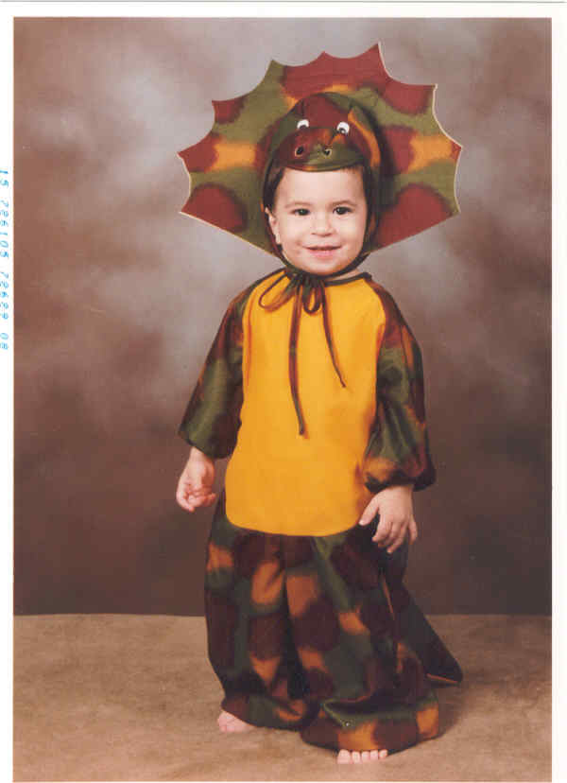
Domenic simply would not go to sleep when he was a baby – at least not at night. After nine months of trying, I decided to let him cry it out one night, no matter how long it took. I put him in his crib around 9:00 pm and shut the door. He cried and screamed until 5:00 am. Then there was silence. When I went and checked on him, he had fallen asleep standing up holding on to his crib rails.
Domenic at age 2

This is Vincent Allegra – yes, a seemingly happy-go-lucky child. For the first four years of his life, Vincent was truly a joy. He was quiet, ate everything on his plate and rarely was sick. Then something happened around age 5. Life became way too Difficult!
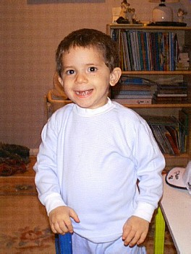

Vincent can be sucking his thumb and cuddling one moment and screaming “That’s my final offer,” the next. He enjoys golf, eating and playing games on the PlayStation 2. He does not like to be interrupted when he is playing his computer games. He is quite proud of himself when he reaches a new level in Scooby Doo or Harry Potter.

Vinny’s favorite pastime is shooting invisible aliens with invisible guns – all day long. Vinny was born on January 19, 2006.
Vinny at age 2
Both boys enjoy Harry Potter. They are really getting in to the movies and can watch them numerous times. For this Halloween, Domenic will be Harry and Vinny will be Harry’s friend, Ron Weasley.
Harry Potter is the brainchild of R.K. Rowling. Domenic will dress in the Quiddich costume and ride on his magic broom while Trick or Treating. Vinny is determined to be the best Ron he can be. He is practicing with his magic wand. It makes three annoying sounds to scare any Hogwart to death.

You think being “Italian” would mean that the boys would love to eat. Afterall, mom and dad have no problem enjoying the scrumptious delights of all types of foods. But the boys couldn’t be more different in their eating styles.
Domenic has not had a fruit or vegetable in about four years. He detests anything healthy. Once in a blue moon, I can get him to take a bit of an apple that is peeled. He is a carbaholic and loves to feast on pizza, hotdogs, McDonald’s chicken nuggets, bread and pancakes.
Vinny, on the other hand, will eat or try any food put in front of him. He loves healthy food and treats!
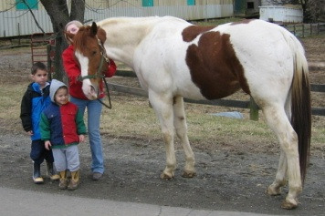
Horsemeat – yum!
YIKES

