Hi – I am Domenic the Dino

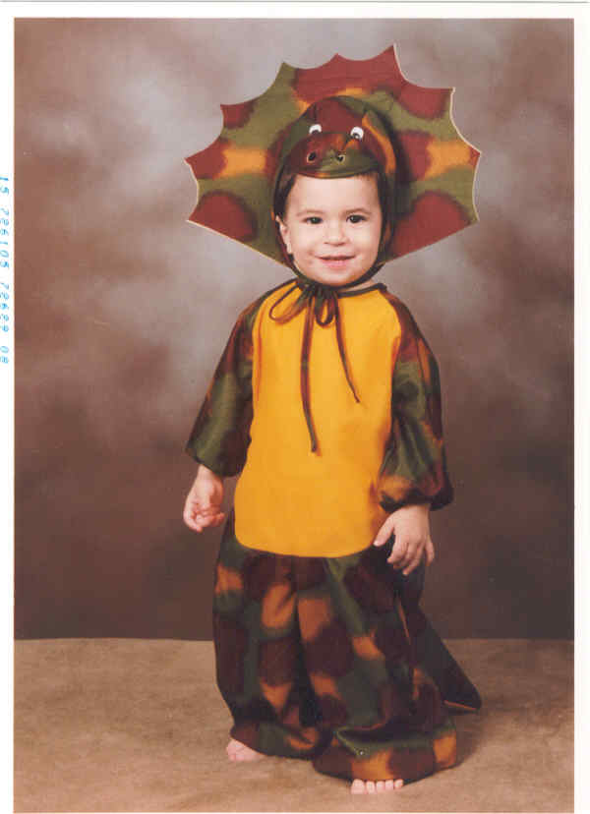

This is my son Domenic who is a real cutie pie. He is now 7 years old and a handful. He is in second grade and does not enjoy school. He’d rather play with Legos and build crafts that sit at a desk and listen to a teacher talk about spelling words and addition.

Options for Pictures and Clip Art

TEXT
1. Insert Text Box:
a. Insert
b. Textbox

2. Text to the left, right or center of picture.
a. Right click on picture
b. Format Picture
c. Layout -- choose what you would like.

LINES
a. Right click on picture
b. Format Picture
c. Colors and Lines

BORDERS and SHADING
a. Right click on picture
b. Select Borders and Shading

CAPTIONS
a. Insert
b. Reference
c. Captions

AUTOSHAPES
a. Autoshapes
Choose Callouts, Basic Shapes, Stars and Banners
b. Drag and fit to size
c.Right Click
d. Insert or Edit n Text

ADDING THE PATH/FILE NAME TO THE END OF THE DOCUMENT
a. Click on beginning of last page
b. Insert>Break>Next Page section break
c. File>Page Setup>Layout tab
d Section Start: New Page
e. Headers & Footers: Different First Page
f. Apply To: This Section
g. Click in last section of text
h. View>Header&Footer
i. Switch to Footer button
j. Insert Auto Text>Filename and Path
[Same As Previous Button (to deselect)

